WOMEN’s AFFAIRS DIRECTORATE

December 29, 2015
Revision April, 2019
ADDIS ABABA
ETHIOPIA
Ethiopian Network for Gender Equality in Agriculture (ENGEA)
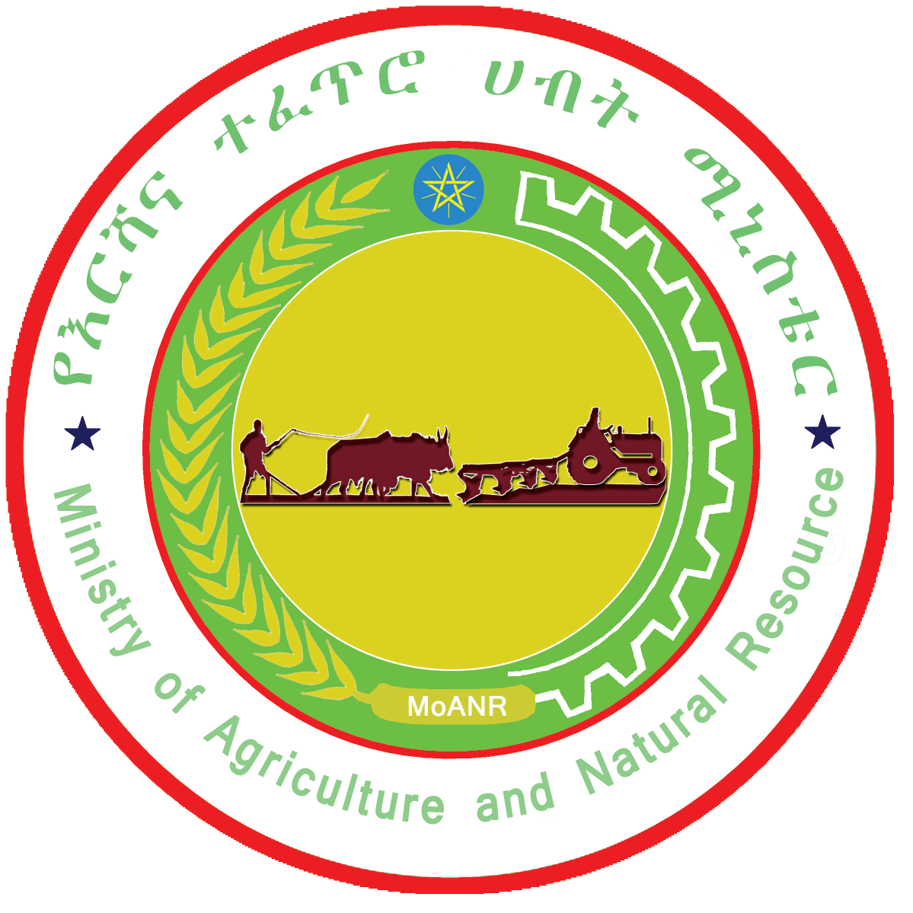

Table of Contents

1. BACKGROUND 1
2. NAME OF THE NETWORK 3
3. VISION 3
4. MISSION 3
5. CORE VALUES 3
6. GOAL AND OBJECTIVES 4
6.1. Goal 4
6.2. Objectives 4
7. Deliverables 5
8. STRATEGIES 5
9. SCOPE 6
10. DATE OF ESTABLISHMENT 6
11. STRUCTURE AND COMPOSITION 8

BACKGROUND

The government of Ethiopia since 1993, has adopted the National Policy on Women to encourage “gender-sensitive” public policies and interventions across government ministries. The constitution has also laid out women’s equality as a right under the law. Article 25 of the new Constitution “guarantees all persons’ equality before the law and prohibits any discrimination on grounds of gender.” Article 35 deals with the rights of women and addresses areas such as affirmative action, customary practices, and property rights, among others. The government is also committed to the Millenium Development Goal (MDG) and the the Sustainable Development Goals (SDGs) and targets and ratified the Beijing Declaration and the Convention on the Elimination of All Forms of Discrimination against Women (CEDAW). The revision of the family law provided better rights for women in terms of land ownership, inheritance, and marriage. The Ethiopian government also introduced a land certification program that requires both the name and picture of the husband and wife and for the female head’s household (FHH) by their own to be issued the certificate.
Gender equality is increasingly being recognized as a critical development issue in Ethiopia. All Federal Ministries including the Ministry of Agriculture are mandated to ensure women benefit from programs, projects and policies. To fulfill this mandate, the MOA has established the Women’s Children and Youth Affairs Directorate which is directly reporting to the Minister, to provide support across the ministry to ensure programs and projects, mainstream gender issues.
Mainstreaming gender in agriculture had been a focus for the Ministry, implementing and development partners. Going forward however there is a need to bring together all these efforts for the purposes of lessons sharing, knowledge management, policy advocacy and national level capacity building. This is expected to contribute towards the improvements in understanding of gender issues and therefore influence the design and revision of policies, programs and interventions from gender perspectives.
Studies in the agriculture sector demonstrates that significant disparities in women's overall access to assets and inputs, the double work burden, as well as the perceived lack of control over production at the household level still exists.On average, female headed households manage smaller plots and cultivate rented fields less than men, have less farm labor, spend less time in agricultural-related activities (because of household related responsibilities, lack of skills and exposure), use fewer inputs (such as fertilizer), have less draught oxen, less access to credit, lower levels of market involvement, less participation in farmer groups, as well as less access to agrictulural advisory services. All of these factors help explain the significant productivity gap that exists between female headed and male headed households. There is also lack of differentially targeting female headed households (who have different needs) than those of married women. National level sex disaggregated data though available these days, needs to be analyzed to feed into policy and programs but also need to be inclusive of married women who contribute equally to the agriculture sector.
In addition to this, the exposure of women to deep-rooted traditional harmful practices is another area that limits the role, contribution and benefit for women from their engagement in the sector. Cognizant of the various challenges, many of the National and government led programs such as, (but not limited to), the Productive Safety Net Program (PSNP), Agriculture Growth Program (AGP), Sustainable Land Management Program (SLMP) have tried to mainstream gender issues. Implementing partners and development partners have also designed project and supported the implementation of interventions aimed at mainstreaming gender issues. However, lessons, experiences, opportunities and challenges still remain within the confines of each of these actors, without knowledge being formally transferred and used widely, resource shared and synergies created. The MoANR’s WAD as per its mandate is therefore taking the initiative to establish, lead and coordinate a network of all partners who have been working and are aspiring to engage and make gender one of their critical agenda in the agriculture sector.
Rationale
This initiative as discussed is aimed at bringing efforts together for experience sharing, networking, advocacy, building the knowledge base and capacity development, to increase efficiency and resource mobilization for the implementation of gender responsive delivery of programs/projects and policies in an integrated manner.
The network will focus on a wide range of national and local interventions on promoting equitable ways of access to, and resource utilization and benefits between men, women, boys and girls. It will focus on strengthening the institutionalization of mainstreaming gender issues in policies, strategies, programs and projects undertaken in the Agriculture sector. It will also focus on monitoring the implementations of agricultural policies and strategies more adequately at grass root levels in achieving gender equality and reducing gender disparities in economic and social wellbeing of female farmers.

NAME OF THE NETWORK

The name of the network “Ethiopian Network for Gender Equality in Agriculture (ENGEA)”

VISION

- To see equal participation and benefits by men, women, boys & girls from the Agriculture sector for improved livelihood and wellbeing.

MISSION

Foster national and regional coordination , advocacy and partnership among stakeholders through evidence based advocacy, capacity development, knowledge and information sharing .

CORE VALUES

The network has the following core values.
- Partnership
- Alignment
- Transparency
- Collaboration
- Team work
- Knowledge transfer and management
- Capacity building and sustainability
- Fairness

GOAL AND OBJECTIVES

Goal

- To ensure gender responsiveness of agricultural policies, strategies, programs, projects and plans as well as actions through coordination of knowledge, lobby and advocacy, experience sharing among stakeholders, systematic analysis and prioritization of issues.

Objectives
  - To create platform to showcase best practices, share information, to manage knowledge, experience, program models and lessons learnt among government and development partners;
  - To create synergies between government, NGOs, development partners and research partners in the development and implementation of gender responsive agricultural policies, strategies, programs, and projects in agriculture sector;
  - To make available, promote and utilize standardized tools and frameworks (gender analysis ,strategic planning, GRB, capacity building) and monitoring and evaluation mechanisms;
  - To build the capacity of stakeholders to advance gender responsive programs in agriculture sector;
  - To address common challenges and opportunities, to facilitate the implementation of interventions aimed at addressing gender inequality issues in and linked to the sector;
  - To enhance effective coordination of programs and avoid duplication of efforts.
  - To advocate and lobby for gender responsive agricultural policies, strategies and programs backed by evidence
  - To have strong linkage with stakeholders /national and international

Deliverables
  - Lessons learnt and best practices on gender responsive agriculture documented and shared
  - Standardized tools and frameworks compiled and shared widely to members and non-members
  - Stakeholders’ Institutional capacity strengthened to promote gender responsive programs in Agriculture
  - Effective coordination of programs by members of the network,
  - Policy issues to engendering agricultural policies, strategies and programs identified and revision or development of new ones advocated
  - Revised polices,strategies and tools communicated to concerned bodies to inform policy/program decisions and actions

STRATEGIES

In achieving its strategic objectives the Network shall work to gain the commitment of all stakeholders which are playing great role in the agriculture sector such as government, development partners, NGOs, experts, researchers, to address Gender inequality gaps in agriculture and other similar issues. To do so, the following strategies will be utilized:

- Organize national workshops, thematic discussions, learning visits and exhibitions on key issues related to gender equality in agriculture and document outcomes on the ENGEA web page.
- Keep the data about the ENGEA members up to date to gain insight in who is doing what activities to improve gender equality in agriculture.
- Share and document tools and guidelines within ENGEA that are related to gender equality in agriculture on the ENGEA web page.
- Actively engage the MoA WAD in ENGEA, jointly organizing learning activities with and for MoA WAD, and link the MoA WAD staff to technical experts in ENGEA that are working on areas they need support on.
- Prepare/ produce policy brief and present to management to MOA through the chair.
- Follow up on Gender Equality Strategy for Agriculture implementation

SCOPE

The network is a platform that is established to serve as springboard to enable government and development partner organizations to come together for collective engagement in narrowing gender gaps in gender responsive programming. In view of this, the network’s scope of services includes, but is not limited to the following:
- National network with regional representation
- Encourage regions to have coordination mechanism for similar purposes
- The sectors in agriculture (Horticulture, Dairy, Livestock, natural resource management)
- Link with other networks within and outside of the countries
- Link with knowledge institutes and private sector actors (national and international)
- With a focus on bringing together coordinated efforts of different stakeholders

DATE OF ESTABLISHMENT

The network was established in Addis Ababa on December 29th, 2015.

STRUCTURE AND COMPOSITION
The network shall be composed of organizations both government, NGOs and development partners which are working on agriculture and have interventions that address gender inequality issues. The network will have the following bodies that will ensure the efficient and effective functioning of the network.
Chair Ministry of Agriculture, Women’s , Children and Youth Affairs Directorate
Organizing a national workshop twice in a year and thematic discussion every month, taking the leadership role of the network, oversee the network activities, to be an agent to link the network with management of the ministry. Sending invitations to members and sharing proceedings, minutes and other documents.
Co–chair ATA and UN Women )– function on behalf of Chair, covering Chair’s responsibility when chair is unable to deliver. Co – Chairing is in rotational based and one organization will serve only for two years.
Secretariat:- AgriProFocus Ethiopia is a Secretary supporting the co – chair in its Secretariat activities for ENGEA due to its wide experience around multi-stakeholder network building and the facilitation skills of multi-stakeholder learning activities. The ENGEA network page is currently part of the AgriProFocus Online Platform and it is linked with MOA under Women Affairs Directorate website. The online platform will be used to announce the upcoming events and to share minutes, reports and other relevant documents communicating with chair. The secretariat will handle the online platform until the MOA – WAD had a capacity to have their own online platform. The secretariat also will support the co – chair in organizing national workshops, thematic discussion and advisory group meetings in taking minutes, supporting knowledge management activities of the network, taking proceedings of the workshop and sharing the same to network member and other stakeholders .
Advisory Team (rotating)-of 12 members Oxfam International, CARE, USAID, CRS, , BENEFIT, SNV, ILRI, EIAR, World Bank, , Canadian Embassy, Orthodox Church Development Organization and the Ministry of Women and Children. The criteria used for selecting the representatives of the Advisory team are:-being active, should volunteer; have interventions on the ground, and ability to fully commit expert’s time. The network will include representatives of NGOs (local and international), Government and its affiliates, Bilateral, Multilateral Organizations representing academia and research entities operating in the sector and on gender issues. Advisory group have a TOR describe roles and responsibilities of the group.
Structure of ENGEA

Members of ENGEA
No | Government | Bilateral and Multilateral Agencies and projects (Development Partners) | NGOs | Remark
1 | - Federal MoWCA,  - WCA standing committee  - Affiliated institutions (15)  - Programs and projects in Ministry of Agriculture (AGP, SLM, PASIDP, PW, PSNP, DRSLP, etc……..  - ATA  - Research Institutions  - Academic Institutions (Universities) | - World Bank  - African Union  - European Union  - African Development Bank  - FAO,  - USAID  - GIZ  - SAA/SG2000  - DFID  - UN WOMEN  - LAND  - LIFT  - SNV  - P4P/WFP  - DFATD/CIDA Canada/  - SSMIP  - LMD,  - ACDI VOCA  - CCRDA  - SIDA  - PEPE (Private Enterprise Program Ethiopia)/DFID  - AKLDP  - AgriProFocus  - ILRI  - CASCAPE  - CAFOD | - Agri-service Ethiopia  - World vision Ethiopia  - Oxfam GB and America  - Digital Green  - Save the Children  - CARE Ethiopia  - FARM AFRICA  - Forum for Environment  - WISE  - Action Aid  - Goal Ethiopia  - Send A Cow  - Christian Aid  - ERSHA  - Ethiopian Catholic Church Social and Development Commission (ECS)  - Lutheran world Federation  - Sustainable land use  - Self Help Africa  - Africa Rising  - Concern Ethiopia  - Enterprise Partners
2 | Regional Bureau of Agriculture Gender units
3 | Regional BOWCA
4 | Networks  - National (Regional and Federal )  - Regional  - International

Federal NegaritGazeta No. 1 27th October, 2010 Common Powers and Duties of Ministries address women and youth affairs in the preparation of policies, laws and development programs and projects
Agriculture includes Crop, Livestock, and Natural Resources

