
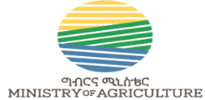

Cellberation of International Womenday (IWD .2025) March 8,2025

Event Report and summries

Date of Cellberation : March 11,2025
Report Complied by WEGO Team

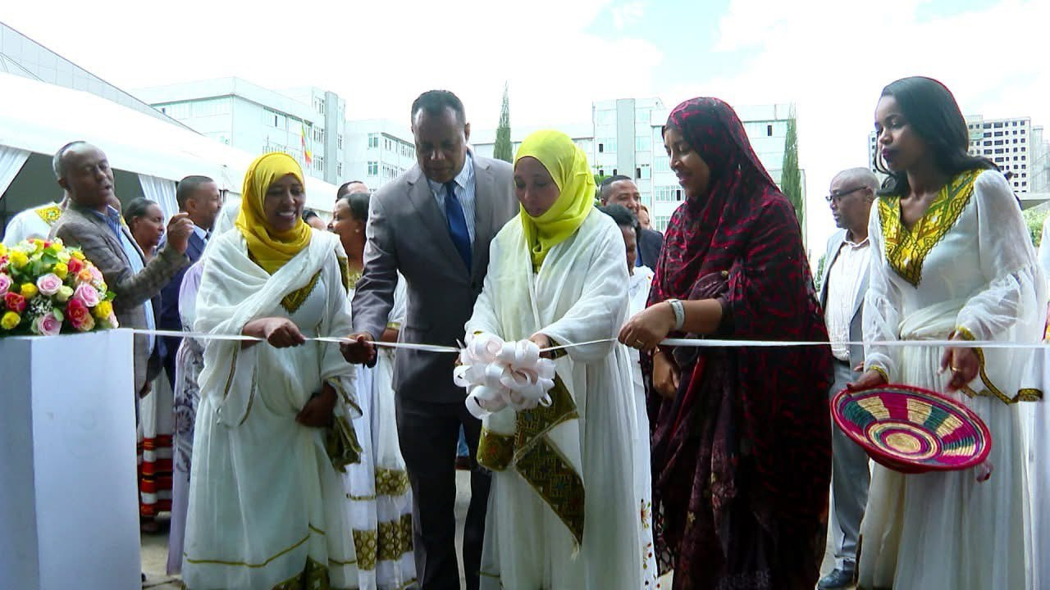

MOA , Addis Ababa , Ethiopia

Table of Contents
1. Introduction 3
2. Major Objective 3
3. Pannel Discussion with leadership, partners and research institutions 3
4. Gender manstreaming activities of excutives , progrmas and projects at MOA : 7
5. Success stories of Women in the agriculture sector : Listening from successful female agri-preneurs 9
6. Summaries of Key sessions 10

Introduction
MOA Women and Social Affairs Executive has organized the celebration of International Women’s Day on March 11,2025 at the premise of MOA. W/ro Genet Abdela, head of WSAE has passed welcoming remarks. State Minister HE. Dr. Sofia Muhaba has made the opening remark and underscored the ministry will continue to its efforts to bring gender equality in agriculture working until equality becomes the regular culture of the ministry. Number of participants in the attendance of the were 166 female, 74 male who came from Minister’s office, Chief Executives, Lead executives, technical experts, administrative staff members, government and non-government organizations, research institutions, programs and projects and media agencies .

Major Objective

- Leadership of MWSA, MOA, research institutions and projects overall reflection on the achievements, challenges and future directions to better gender equality as the nation and in the agriculture sector
- Listening from successful female agri-preneurs
- To illumintae gender manstreaming activities of excutives , progrmas and projects at MOA

Pannel Discussion with leadership, partners and research institutions

Leadership of MWSA, MOA, research institutions and projects overall reflect on the achievements, challenges and future directions to a better gender equality as the nation and in the agriculture sector.

Four individuals participated in the panel discussion
- HE State Minister W/ro Hikma Hayredin from MWSA,
- HE Dr. Sofia Kasssa, State Minister MOA
- W/ro Aynie Habtamu, Program Coordinator from WEGO Program, CARE Ethiopia
- Dr. Muluembet Zenebe, Addis Ababa University Center for gender Studies
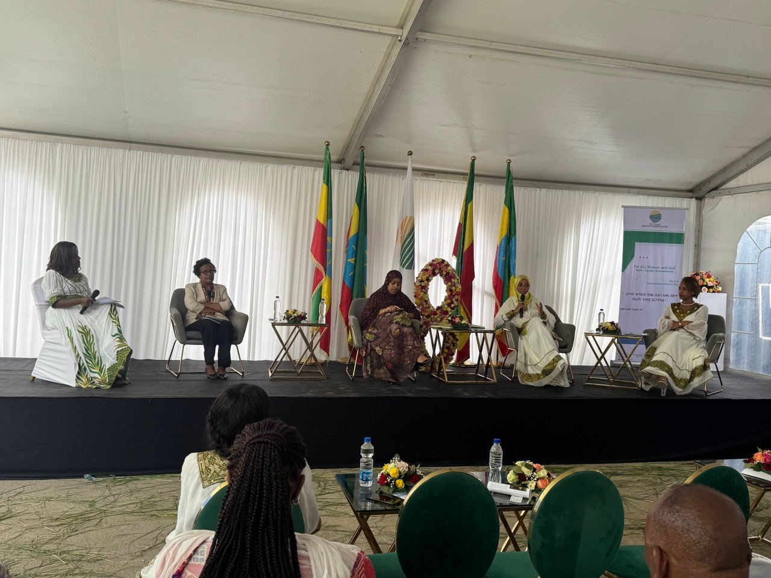
Speaking about the achivements and challnges so far as a country in gender equality
W/ro Hikma Hayredin , State Minister highlighted there are various improvements registered in Ethiopia benefiting women across social, political, and economic sectors.
She pointed out that in the social sector, education is showing progress, particularly with a closing gap in primary education for grades 1-5, where there are currently about 4 million students enrolled. Women’s decision-making roles are expanding, particularly in universities, where more are being appointed to positions such as presidents and school directors. However, overall participation in decision-making still requires more improvement. In terms of health, there have been positive changes with an increase in the number of women receiving deliveries attended by trained professionals in well-equipped facilities. Politically, the representation of women has significantly increased; previously, the Ministry of Women and Social Affairs was exclusively female, but now women make up 49% of the HPR, and in kebeles, 50% of the representatives are women. Women also hold positions in the judiciary and executive branches, with equal representation at the ministerial level. Economically, women are gaining from skills development and job creation initiatives.

HE Hikma has identified the following as matters of concern
- When women have financial independence, it enhances their respect within the household and the community, helping to lift them out of poverty.
- it's important to note that issues like domestic violence persist, with some still viewing it as a societal norm.
- Additionally, many women remain deprived of decision-making power, underlining the need for continued advocacy and change.

The next panelist was Dr. Sofia Muhaba she spoke gender equality work in the agriculture sector and the participation of women in the investment. Dr. Sofia emphasized that women’s vital role in the agricultural sector remains largely unrecognized. Women are crucial players in the agriculture sector. They dedicate their time from morning until night, contributing far beyond just production. They wake up early to provide food and manage animal husbandry, all while taking lunches to their husbands and handling harvesting and weeding. Alongside their other responsibilities, women bear the additional burden of seedling preparation, which can be both physically demanding and time-consuming.
HE Dr. Sofia has indicated
- It is essential to acknowledge and value the significant roles women play in agriculture and for their hard work and dedication. Women’s commitment to agriculture remains strong, highlighting the need for more support and resources aimed at empowering women in the sector.
- Program design should keep closer attention to modernize and reduce burden of women are loaded with in every activity they engage in .

- The extension should be for women alone. We emphasize this because we need to consider their time constraints. The locations are often far, and when they go, they have to bring their children along. It's important to provide a place where they can rest and feel comfortable.

Women in agricultural investment:

- Women involved in agricultural investment face numerous challenges. Their investments are often overlooked, and there is a lack of acknowledgment for their hard work. Many women encounter discouragement, and the overall environment is not conducive to their success.
- there is a shortage of capital accessible to all investors, and while there are some initiatives in place, they are not enough to meet the rising needs of women in this field.

- Women in agricultural investment often face significant challenges that hinder their success due to lack of support and encouragement. The environment they work in is not always conducive to their growth, even though the quality of their farms and investments is high.

- Just like male investors, women deserve equal treatment and support in the sector. There needs to be dedicated platforms to encourage and empower women in agriculture.
- More efforts are needed to ensure that women receive the recognition and resources they deserve.

Dr. Emebet from Addis Ababa University Center for Gender Studies said presented the center has done review of researches and publications made on the subject of gender in agriculture in the last 15 years . The research review has classified two sets of works ,those that are done on positive changes and achievements and those that present gaps and challenges .
Studies on the positive and progress made related to gender and agriculture showed gender equality strategy is a valuable initiative, especially since it highlights land ownership benefits and the importance of extension programs that provide information and training. It's encouraging to see studies that acknowledge women's knowledge in various areas, such as forest protection, food security, and animal husbandry. The struggles faced by women, including fighting against early marriage and advocating for land rights, are crucial issues that need attention. The example of women in Tswa Mahiber standing up to express their concerns shows the empowerment that social associations can bring. Their participation enhances their voices and helps address important issues within the community, ultimately contributing to a more equitable society .
There are several studies on the problem side
- what needs of women as similar to needs of men - making the need the same . Making agriculture as men’s making if women farm land will dry
- Land ownership, not allow women to inherit to children
- If husband get the information wife gets
- Workload: what do you want a woman asked and she said I want a time to take rest
- Market related studies
- Natural and manmade disaster : women are affected more in those situations
- Taking all women as the same women headed women under male headed hH
- Over all the cause of the problem can be the place women have in the community
Partner organization
The representative from WEGO She highlighted the program objectives and has presented the achievements of WEGO program in terms of women empowerment in the two regions , four Worda and 40 kebles . She emphasized the importance of designing programs that are participatory, incorporating two-way discussions to better understand the needs of the government. This approach is vital in ensuring that the programs are relevant and effective. The WEGO program was developed specifically to address the gaps identified by the WSIE, aiming to create solutions that meet both community and governmental needs. This collaborative effort reinforces the significance of stakeholder engagement in program development.
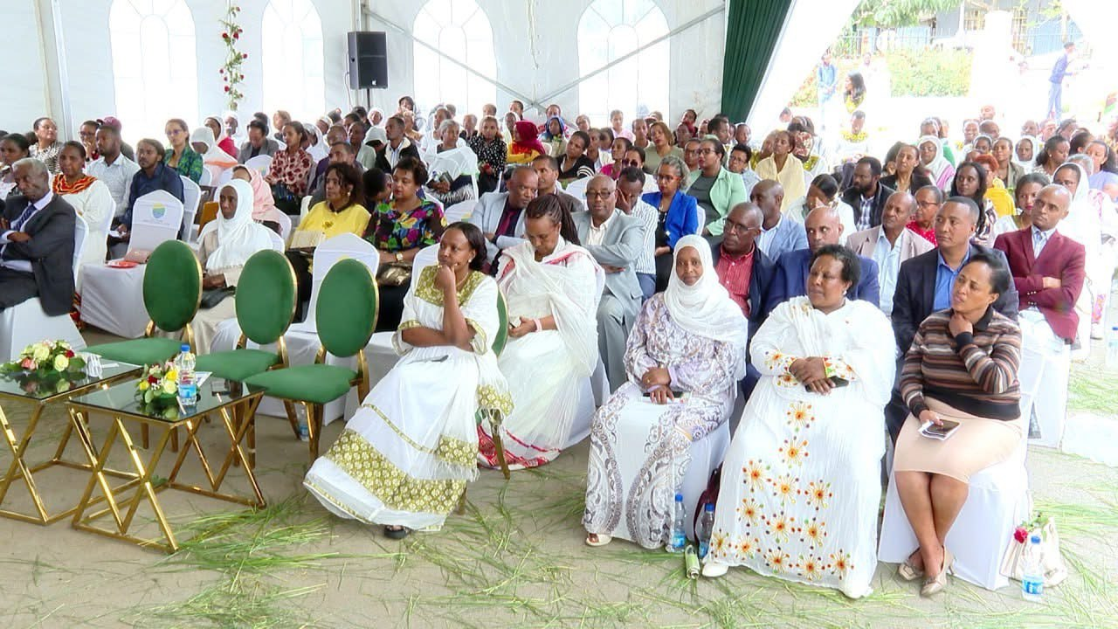
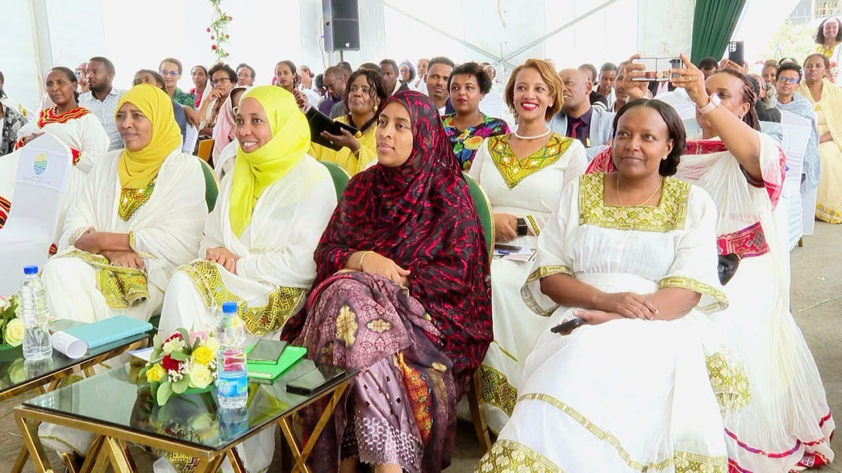
- Gender manstreaming activities of excutives , progrmas and projects at MOA

Banner-based presentations show that
- Women and Social Affairs inclusion Executive: reported several capacity building training activities.
Identified documented proportion of female and male in capacity building.
Reported work on practical needs (food heroes. It has shown strategic work done in the working unit (engaging in researchers)
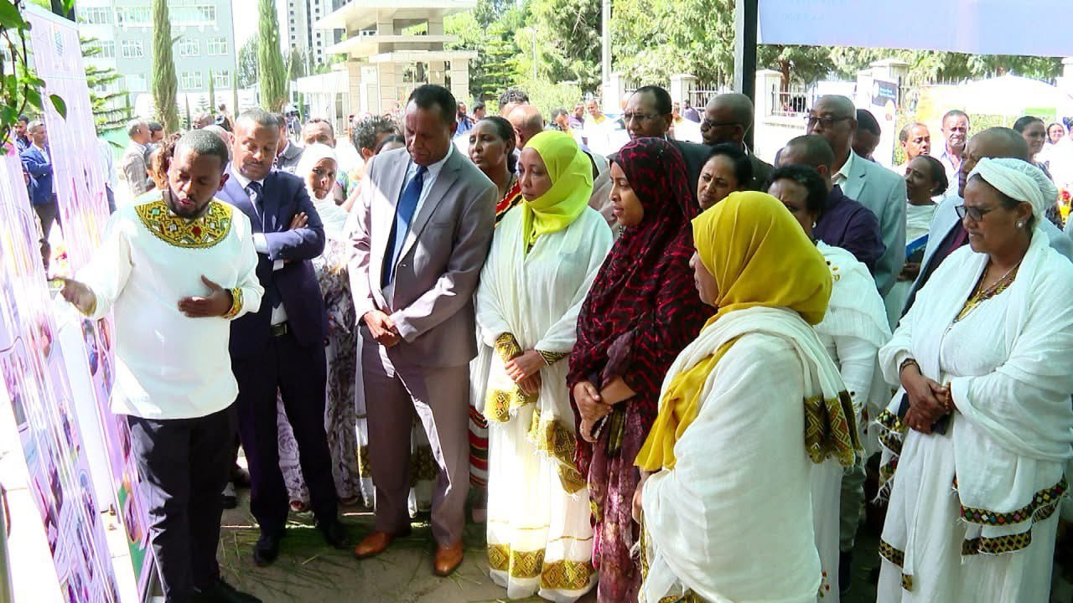
- Agriculture and Horticulture Extension Lead Executive – identifies targets as female constituting 50% of farmer and field school group. Categorizes participants in various categories (FHH, MHH and youth). It has strategic issues such as guideline development and staff capacity.
- Cotton development: gender equality challenges are stated about women in the cotton value chain labor contributors and does not show policies or mechanisms that can dictate the sector and work on that regard.
- Soil development : no gender disaggregated data. Does not show gender gap issues of the sector . does not identify women in comparison with men .
- Agricultural investment : provides female participation in the investment sector . But it does not show what their status like in foreign currency contribution , provision in raw materials supply to agro industry and how much they created and benefited in job opportunity .
- Urban agriculture has shown the proportion of women and men in the diary development , poultry , bee , meat development , vegetable and fruits . crop , natural resource sectors . However , all the participation of women in the report demonstrate women are still in the traditional level and does not indicate male engagement and presenting challenge to change gender division of labor .
- Fisheries Development :
shows the gender gap and participation in the sector’s employment. Has indicators for strategic and practical issues income generation, job creation, foreign currency , food and nutrition , improved decision making , community bond . Still the percentage and proportion should be stated for all segments not just one .
- Mechanization has women targeted activities on operator trainings for women , pump and sprayer hand over , labor and energy saving technologies ,Ense technology .This does not tell how many the women constitute out of the total targets wise , region wise . Does not show how they have made the technologies be women friendly and needs based. What activities are done to tackle gender inequality is not stated clearly.
- Food and nutrition office: improving dietary diversity at household level goal was presented . This department has not indicated if women were the only program targets . The activities seem to make women the only members of family working for nutrition sensitive agriculture . That is not gender transformative .
- FSRP program has been working at program strategies and guideline levels for women empowerment. This program also put women are 29% of its beneficiaries. This number is known in percentages. They may think to raise it to 50%.
- PSNP Program has gender transformative approaches to integrate gender considering both strategic and practical needs. It has targeted 50% women in its program activities.
- Participatory Small Scale Irrigation Development Program II has gender model family approaches, community sensitization on GMF and other gender equitable practices like hh decisions and harmony in the family .
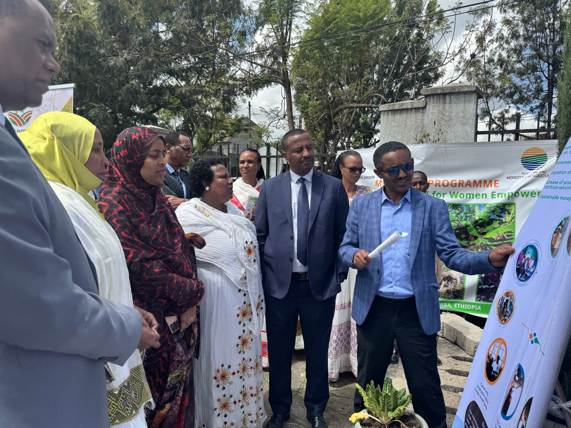
- Second Resilient Landscape and Livelihoods Project (RLLP-II) calculates the total participants as male and female but women in MHH are not explicitly mentioned. The female stories are about FHHonly .
- Climate Action Through Land Scape Management Performance for Result (CALM) Program . This program sets clear percentage for women participation.
- Inclusive and Sustainable Value chain development Project (ISVCD) in Oromia, SIDAMA and South Ethiopia Regions. It has a standalone objective for women and youth integration . It does not quantify the participation of women and men in the program. The example of activities in the banner show women in subsistence producing for household consumptions. The activities do not show shifting traditional gender roles that women are the only responsible bodies for cooking and its demonstration. They were not seen in higher levels of value chains such as processing.

- Success stories of Women in the agriculture sector : Listening from successful female agri-preneurs

  - The former school teacher 11 years ago Wro Kibret Alemayehu is one of the panelists who shared her success and is involved in an agriculture investment. She started farming in Metu and Bensgangul. She is now involved in the export of oilseeds and pulses and importers of medicine, developing software and poultry in the Oromia region. She was a teacher and started agriculture on the side. Now she is studying for a PhD and developing Software.
  - Womitu : W/ro Womitu Bushira shared that she used to depend on her husband’s pocket for each thing needed every day. From going to trainings given for rural women gradually improved her knowledge and self-awareness She become motivation to start business. and moved into vermicompost production and made a lot of profit. Because of the income, he bout additional farm land, her family livelihood is improved, her children got good education, she continued to expanded her business to milk production, created jobs for others and has joint account with her husband and and personal account she fully controls . People had poor attitude towards her economic activity as not relevant and discouraged her from starting on income generating but now her capital is more than 900 thousand bir. Womitu said it is the training given for her rural community that has opened her eyes to see opportunities instead of being reliant only on her husband’s pocket. “It was very useful. I liked it and kept going without telling where I was. I decided to start small business” Now she has more than 900000-birr capital.

  - W/ro Azeb now has a 500-million-birr capital started her agri business in 15000 birr. She is engaged in livestock husbandry, poultry, bee kepping . She created job opportunities for 20 workers. She has become successful in agribusiness despite her physical disability from polio.

- Summaries of Key sessions

- The discussions presented by MWSA, MOA, research institutions, and partner organizations reveal progress and persistent challenges in achieving gender equality, particularly within Ethiopia's agricultural sector. Significant strides have been made in social, political, and economic spheres, demonstrated by increased female enrollment in education, improved healthcare access, and enhanced political representation. However, critical issues remain, including the undervaluation of women's contributions to agriculture, persistent domestic violence, limited decision-making power, and unequal access to resources and opportunities. Research highlights the need to move beyond a one-size-fits-all approach, recognizing the diverse needs of women and addressing systemic barriers like land ownership and workload disparities. The importance of participatory program design, exemplified by the WEGO program, emphasizes the necessity of collaborative efforts to ensure that interventions are relevant and effective. To achieve meaningful and sustainable gender equality, a concerted effort is required to acknowledge and address the specific challenges faced by women in agriculture, empower them through targeted support and resources, and transform societal norms that perpetuate inequality.

- The above presentations from the sectors and programs reveal a mixed landscape regarding gender integration across various agricultural sectors and programs. While some sectors, like Agriculture and Horticulture Extension and PSNP, demonstrate a commitment to gender equality by setting targets for female participation and developing gender-sensitive guidelines, others, such as Soil Development and Agricultural Investment, lack gender-disaggregated data and fail to address gender gap issues. Notably, programs like Fisheries Development and Urban Agriculture provide some data on female participation but often portray women in traditional roles, hindering gender transformative change. Furthermore, several projects, including Cotton Development and ISVCD, lack clear policies or mechanisms to address gender inequalities within their sectors. The FSRP and RLLP-II programs show improvement in targeting women but still need to improve the quality of their reporting and ensure that women are participating in higher level activities.
To achieve meaningful gender equality, programs should prioritize the collection and analysis of gender-disaggregated data across all sectors. Implement clear gender policies and mechanisms, particularly in sectors like cotton development and agricultural investment, to address existing inequalities. Move beyond merely targeting women's participation to actively promoting gender transformative approaches that challenge traditional gender roles and empower women in higher-level value chain activities and decision-making processes. Ensure that capacity-building training and technology adoption programs are designed to meet women's specific needs and consider regional variations. Regularly monitor and evaluate the impact of gender-focused interventions and use the findings to refine strategies and improve program effectiveness. Strengthen reporting practices to include both quantitative and qualitative data that accurately reflects women's experiences and contributions, including women in male headed households.

- These success stories powerfully illustrate the transformative potential of empowering women in agriculture and entrepreneurship. Despite facing diverse challenges – from societal discouragement to physical disability – Wro. Kibret Alemayehu, W/ro Womitu Bushira, and W/ro Azeb have achieved remarkable success. Their stories highlight the critical role of capacity-building training, access to resources, and personal determination in enabling women to break free from traditional constraints and become key economic contributors. Wro. Kibret's diversification into multiple sectors, including export and technology, showcases the breadth of women's potential. Womitu's journey from financial dependence to a thriving vermicompost and dairy business underscores the impact of targeted training on rural women. Azeb's achievement, building a 500-million-birr agribusiness despite physical limitations, serves as a powerful testament to resilience and entrepreneurial spirit. Collectively, these women demonstrate that investing in women's economic empowerment not only improves individual livelihoods but also drives broader economic growth and creates opportunities for entire communities.

